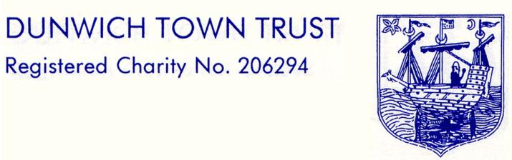

MINUTES OF THE MEETING OF THE TRUSTEES
HELD ON MONDAY 11th SEPTMBER 2023 AT 6.10 PM
IN THE READING ROOM, DUNWICH

1. WELCOME AND APOLOGIES FOR ABSENCE:

Present: Gussie Andersen (GA) Chair
Dennis Cox (DC) Vice Chair
Julian Perry (JP) Trustee
Nigel Barham (NB) Trustee
Sharon Earp (SE) Trustee
Jon Dawson (JD) Book-keeper
In Attendance: Julia Davison-Wilson (JDW) Clerk
Apologies: Val Bethell (VB) Trustee,
Jane Hamilton (JH) Trustee, Henry Tomlinson (HT) Trustee,
Rod Smith (RS) Trustee

It was confirmed that a quorum was present.
Trustees' Declaration of Interest: None
Action
2. | MINUTES OF THE LAST MEETING OF 10TH JULY 2023 :  As no amendments had been received, the minutes of the meeting of the 10th July, 2023 were unanimously approved.
3. | MATTERS ARISING:  As no amendments had been received the corrected minutes and confidential minutes of the meeting of the 15th May, 2023 were approved.  GA and JD sent a cheque to Dunwich Museum to cover the cost of the Coronation mugs that were given away. SE displayed her A4 DTT explanatory and contact poster on both village notice boards. HT and NB, as Dunwich residents, tested free access to Minsmere car park and found that it worked. The matter is now with the DPM.
4. | CLERK’S REPORT:  See confidential minutes for items.
5. | CAR PARK/BEACH:  See confidential minutes for items.
6. | FINANCIAL REPORT  The bank accounts are in good shape with a good net income. JD now has Trustees’ signatories to access the Investment fund and will soon have access to this account.  Both the restricted and unrestricted funds have grown more in 2023 than in 2022. JD circulated example rent increase amounts of 2.5%, 5.0 %, 7.5% and 10% to aid the Trustees in their rent review decision.
7. | GOVERNANCE:  DC’s review of Policies – 6 policies, Risk Assessment, Investment, Conflict of Interest, Complaints, Reserves. After discussion it was decided the Clerk should circulate them to all Trustees for review and the review will be an item on the Agenda of the November 13th meeting. | JDW
8. | HOUSING:  Rent Review  See confidential minutes for items.  Repairs  This item is covered in the confidential minutes
9. | GRANTS:  One grant application received from the Parish Meeting. This item is covered in the confidential minutes.
10. | WEBSITE:  The Grants section has been updated, and more grant forms uploaded in Word form.
11.  12. | A.O.B.  No matters arose.  DATE OF NEXT MEETING:  13th November 2023 6 pm Dunwich Reading Room. GA will do refreshments.

The Meeting closed at
8.15 p.m.

Signed: ......................................................................... Date: ...................................................................

