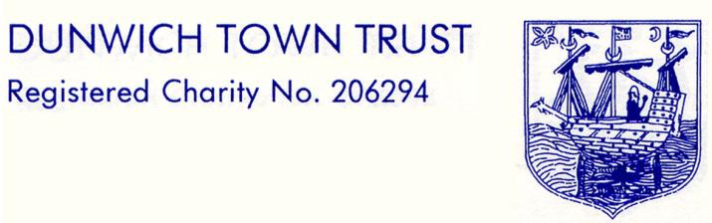

DUNWICH TOWN TRUST
MEETING SCHEDULED FOR MONDAY 11 MAY 2020
IN THE READING ROOM, ST JAMES STREET

MINUTES

** Due to Covid 19 restrictions the Trust had reference to the Charity Commission’s guidance on conducting a meeting without face-to-face contact. There was no clause in the Trust’s governing documents to permit other means of meeting but Trustees decided to deal with the business of the meeting by e-mail to demonstrate good governance of the charity. **

- Welcomes and Apologies
Present via e-mail:
Miss Nick Mayo (NM) (Chairman)
Ms Gussie Andersen (GA) (Vice- Chair)
Mr Crispin Clay (CC)
Mrs Val Bethell (VB)
Ms Jane Hamilton (JH)
Dr Dennis Cox (DC)
Mr Rod Smith (RS)
In attendance via e-mail: Mr John Lavery (Clerk) (JL), Mrs Nicky Kinahan (NK) (Treasurer).

- Minutes of Meeting on 9th March 2020
No amendments had been notified since the minutes were circulated. They were therefore approved via e-mail by the Trustees. They would be signed off by NM as a true record at the next meeting.

- Matters Arising from the Minutes
The work on the paling fence had been completed by Fran Cousins. NM had a spare key to unlock the gate to the marshes and had checked that it worked. This would be handed to C Elsley to keep when restrictions allowed contact. NM also had the second warning sign for the beach hut and this would be put up when possible. The Clerk had received 2 responses for the beach novelty rubbish / recycling container competition, but it seemed unlikely that the judging would take place in July, as originally planned. The contestants had been made aware that a delay was likely. The other action points in the previous minutes had been postponed due to the coronavirus lockdown and would be addressed as soon as possible.

- Clerk’s Report
The Clerk’s report was circulated by e-mail. Any items outstanding were reported in these minutes.
- Car Park/Beach
The beach car park was closed at Easter at the request of the Police and would remain closed until the lavatories and café were re-opened. East Suffolk Council and Norse were being cooperative over these practicalities. Thanks were due to RS for dealing with these two organisations on DTT’s behalf.
The beach refuse container competition would now need to wait for an Open Meeting or other village event to be judged. A prompt would be put round, as only 2 entries had been submitted to date.

- Treasurer’s Report and Financial Matters
This section was reported in the Confidential Minutes

- Housing
Trustees had been kept informed by e-mail of developments since the last meeting, in respect of both domestic and business tenancies and rents. Where appropriate those tenants who had been furloughed, those who were self-employed, or covered by the Hospitality fund had been referred to Government schemes. NM had taken advice from C&S and had agreed to defer rent payments where hardship would otherwise be caused. This would be subject to agreeing repayment programmes with tenants, when their circumstances permitted.

- Grants
This section was reported in the Confidential Minutes

- AOB
NM had been in contact with the National Trust about timing the reopening the beach car park to visitors, with a view to coordinating the opening of public spaces as much as practicable.
Due to the circumstances surrounding the Covid 19 restrictions, the Open Meeting planned for the 3rd July would be postponed or possibly cancelled this year.

Signed: …...................................................... Dated: …....................................

